SFMC Outgoing Data to Azure
Current SFTP Method

Workflow Overview
The integration process is designed to automate the flow of data from SFMC tables to Azure, ensuring that data is regularly updated and available for analysis and reporting.
The reasons for this process are:
- To further extend the reporting capabilities of Salesforce Marketing Cloud (6 months)
- To provide an easier and faster way to organize data outside of Marketing Cloud
- To utilize the advanced data visualization and interactive UI/UX features of Power BI
- To supply greater sharing capabilities between Salesforce Marketing Cloud and OCM Managers
:tick: This process has been approved by both the ISRM (Information Security Risk Management) and VPCx (Virtual Private Cloud) teams at JNJ.
Additional information can be found in the contacts tab.

Workflow Diagram
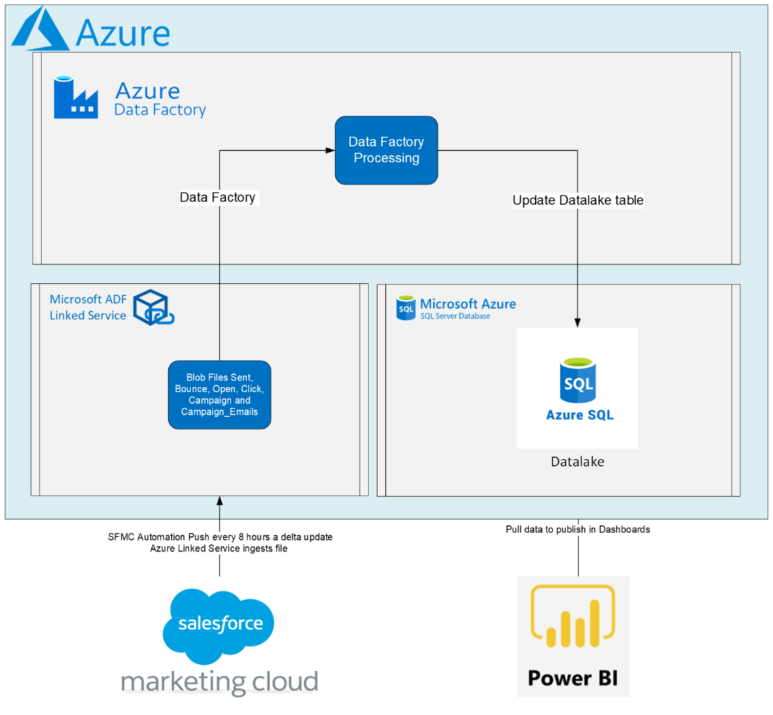

Power BI Report Access
Access the Power BI reports here: Power BI Marketing Data Reports

Current Integration Steps

Step 1: SFMC Automation Execution
- Frequency: Every 4 hours (12AM, 4AM, 8AM, etc... GMT)
- Description: SFMC runs the AzureAutomate_automation to extract delta data for Sent, Bounce, Open, Click, and Jobs data views, along with custom campaign data.
:information: Additional Notes:
- Automation Name: my automations/Reports/AzureAutomate/AzureAutomate_FTP_Only
- Automation runs in GMT, SFMC does not change with daylight savings, the time of the automation changes based on time zone, could be 12:00AM or 1:00AM based on daylight savings

Step 2: Data Load to SFMC SFTP
- Action: Extracted files are transferred to our File Transfer Protocol storage from Salesforce.
- Purpose: To serve as a staging area before data processing.
:information: Additional Notes: SFTP Host Address: *.ftp.marketingcloudops.com

Step 3: Processing with Azure Data Factory via SFTP Linked Service
- Action: Azure Data Factory picks up the data from the SFMC SFTP using Linked Service.
- Processing: Data is transformed, validated, and cleaned as per the defined ETL (Extract, Transform, Load) processes.
:information: Additional Notes:
- ADF name is "azrhhwadfdev", this is a Managed Virtual Network Integration Runtime (IR)
- This file is picked up by SFTP Linked Service at 1:30AM, 5:30AM, 9:30AM, 1:30PM, 5:30PM and 9:30PM EST (can be 30 minutes or 90minutes after SFMC automation depending on daylight savings)

Step 4: Data Load into Azure SQL Data Lake
- Action: Processed data is loaded into Azure SQL.
- Result: A data lake that mirrors the SFMC data views is created, enabling complex queries and analysis.
:information: Additional Notes: DB is "euzazramtprod", this is an Azure SQL Database, tables start with "dbo.SFMC_"

Step 5: Reporting with Power BI
- Action: Power BI connects to the Azure SQL data lake.
- Outcome: Interactive reports and dashboards are generated, providing insights into the marketing data.
:information: Additional Notes: Click here to access the Power BI

